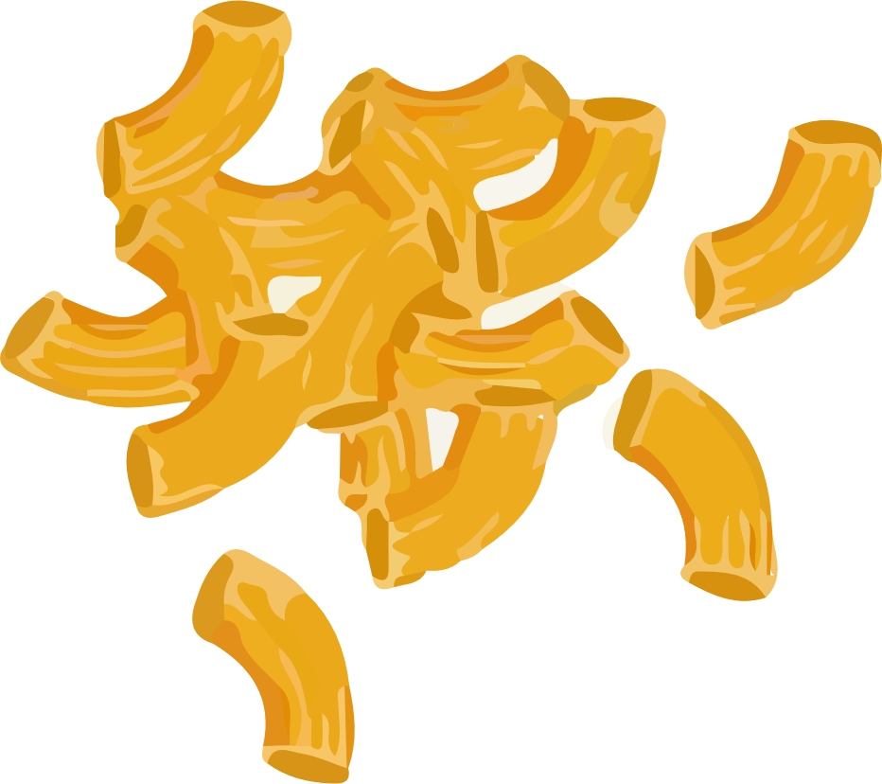
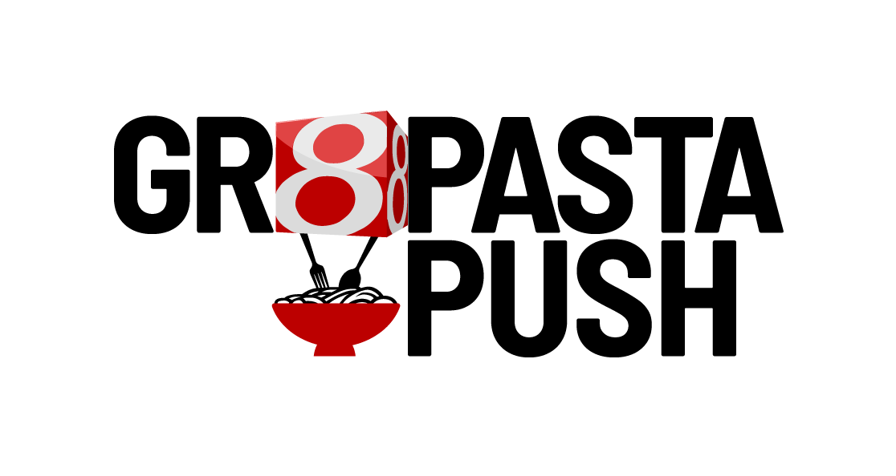
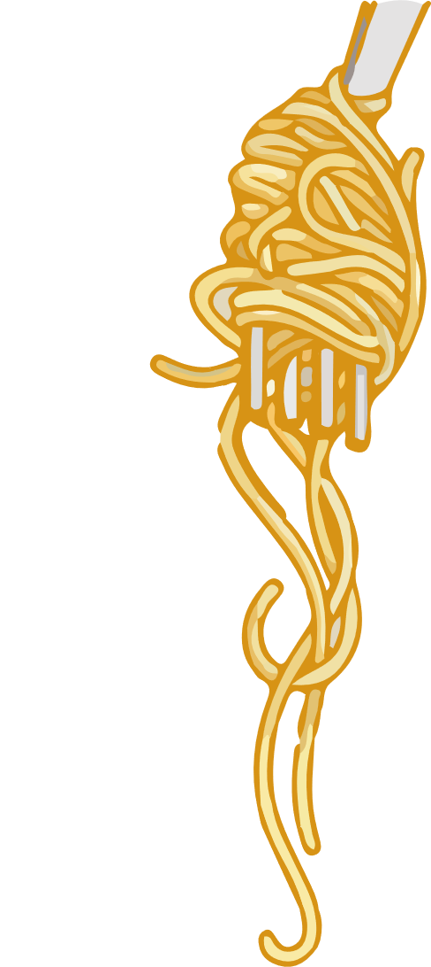

We are participating in a community-wide pasta and fund drive to fight hunger with Second Helpings this June.

Second Helpings relies on pasta drives to bring much needed non-perishable food to prepare nutritious meals in their Hunger Relief kitchen. Second Helpings uses 1,000 pounds of pasta per week, so the pasta we collect will be put right to use feeding Indy!
The pasta we collect will be used to create nutritious meals for people in our community who may otherwise not get a full meal today.
Nutritious meals are distributed to shelters, senior centers, after-school programs, and also delivered to the homes of those who can’t access food any other way.
Second Helpings’ priority item is
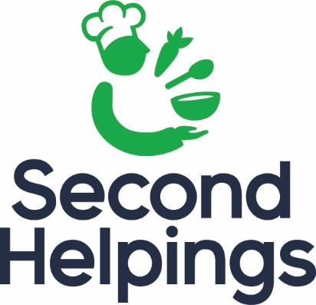
ELBOW MACARONI.

